



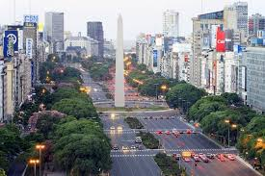
On July 9, Argentina celebrates its Independence Day (Spanish: Día de la Independencia). It is one of the country’s most important national holidays.
On July 9, 1816, Argentina officially declared independence from Spain during the Congress of Tucumán.
People in Argentina celebrate with:
Parades
Fireworks
Traditional music and dancing
Gaucho (cowboy) festivals
Family gatherings
Traditional foods like empanadas and locro

One of the most famous streets in Buenos Aires is called Avenida 9 de Julio in honor of Independence Day.

